Tobin's q

Intro

is the ratio between a [physical asset](https://en.wikipedia.org/wiki/Asset)'s [market value](https://en.wikipedia.org/wiki/Market_value) and its [replacement value](https://en.wikipedia.org/wiki/Replacement_value).

Def

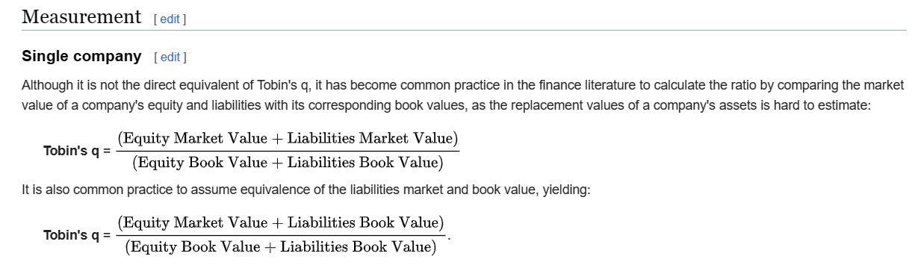

Ratio

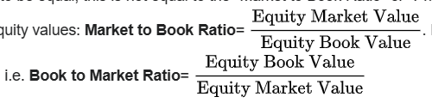

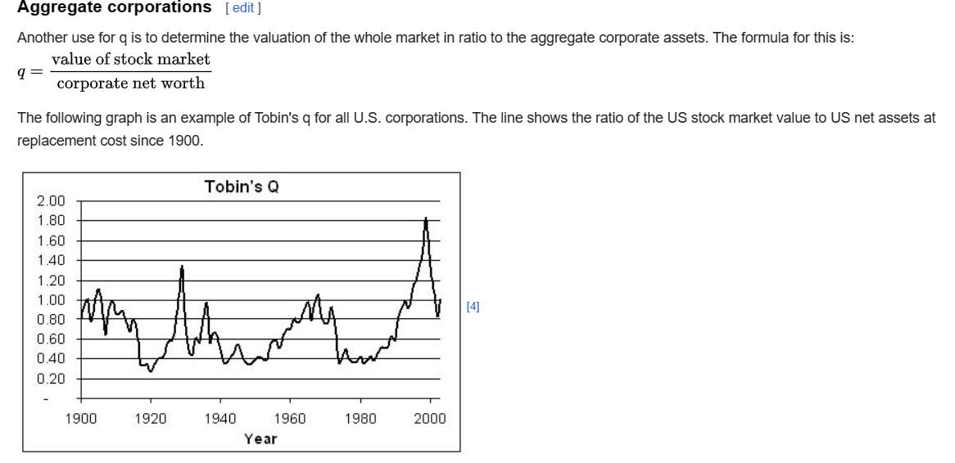

Ref

[Tobin's q - Wikipedia](https://en.wikipedia.org/wiki/Tobin%27s_q)